Customer Behaviour Analysis using Python, SQL & Power BI

Name: KISHORE.K
Date: April 2026
Introduction
This project focuses on analysing customer behaviour using a dataset collected from Kaggle. The data was processed and cleaned using Python (Pandas), stored in PostgreSQL, and analysed using SQL queries. Finally, an interactive dashboard was created using Power BI to visualize key insights.
Objective
The main objectives of this project are:
- To analysed customer demographic details
- To understand feedback patterns
- To identify trends in occupation and income
- To extract meaningful insights using data analysis tools

Data Preparation
The dataset was first imported from Kaggle and processed using Python. Data cleaning steps included:
- Removing duplicate records
- Handling missing values
- Standardizing column names
- Ensuring proper data types
After cleaning, the dataset was imported into PostgreSQL. A structured table was created, and SQL queries were used to analysed the data efficiently

SQL Analysis
-- Count total records
SELECT COUNT(*) FROM customers;
Result: 388
Insight: The dataset contains 388 customer records.

-- Gender distribution
SELECT gender, COUNT(*)
FROM customers
GROUP BY gender;
Result:
- Male: 222
- Female: 166
Insight: The majority of customers are male.

--Feedback distribution
SELECT feedback, COUNT(*) FROM customers GROUP BY feedback;
Result:
- Positive: 317
- Negative: 71
Insight: Most customers provided positive feedback, indicating overall satisfaction.

Average family size
SELECT AVG(family size::INT) FROM customers;
Insight: The average family size is approximately 3–4 members.

Power BI Dashboard
An interactive dashboard was created using Power BI to visualize the data.
🔹 Gender Distribution Chart
This bar chart shows the number of male and female customers. It highlights that male customers are slightly higher.
🔹 Feedback Distribution Chart
A pie chart was used to represent customer feedback. The majority of feedback is positive, showing good customer satisfaction.
🔹 Occupation Chart
This chart displays the distribution of customers based on occupation. Students form the largest group.
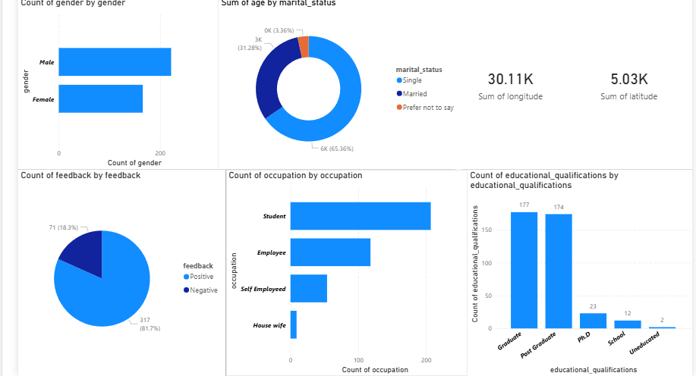

Key Insights
- Most customers are male
- Positive feedback dominates the dataset
- Students are the largest customer group
- The average family size is moderate (around 3–4)
- Customer satisfaction is generally high

Conclusion
This project successfully demonstrates the process of data analysis, from data cleaning to visualization. By using Python, SQL, and Power BI, meaningful insights were extracted, helping to understand customer behaviours effectively.
Future Scope
- Implement machine learning models for prediction
- Enhance dashboard with more interactive visuals
- Perform deeper segmentation analysis

data
Resources:
SQL
Resources:
EXCEL
Resources:
Power BI
Resources:
Python(Pandas)
Resources:

README.md
# Customer Behaviour Analysis

This project analyses customer data using Python, PostgreSQL, and Power BI.

## Tools Used
- Python (Pandas)
- PostgreSQL
- Power BI

## Key Insights
- Majority customers are male
- Positive feedback dominates
- Students are major group

## Files Included
- Dataset
- SQL queries
- Dashboard
- Report

Final Folder Structure
Customer-Behavior-Analysis/
│
├── data/
│ └── clean_food_data.csv
│
├── sql/
│ └── customer.sql
│
├── excel/
│ └── customers.ods
│
├── powerbi/
│ └── customers.pbix
│
├── python/
│ └── food.py
│
└── README.md

